Contact:
Lars Führmann
lars.fuehrmann@lpkf.com
Tel. +49 (0)5131 7095-1591
Fax +49 (0)5131 7095-90

LPKF
Laser & Electronics AG
Osteriede 7
D-30827 Garbsen
www.lpkf.de

Board of Managing Directors:
Klaus Fiedler
Christian Witt

Shares:
Prime Standard
ISIN 0006450000

Print free of charge, copy requested

Always the best tool

LPKF ProtoLaser H4 accelerates PCB prototyping
Sometimes the laser is the tool of choice, sometimes a drill, sometimes a milling cutter. If you use the LPKF ProtoLaser H4 for circuit board prototypes, you don't have to worry too much about it. The latest device in the ProtoLaser series decides independently and is therefore even more flexible than its predecessors. This is proven by a practice report in which a 4-layer PCB is produced in-house in just one day.
The ProtoLaser H4 has more than 45 years of experience in the mechanical processing of printed circuit boards and more than 30 years in laser processing. This experience is combined in the hardware and the LPKF CircuitPro system software included in the package. “The goal was a compact table-top system that would also convince the most demanding developers of electronics on different substrates. And it works,” says Lars Führmann, Sales Director LPKF DevelopmentQuipment with satisfaction. The new ProtoLaser is built on a granite base, has a powerful laser and a mechanical processing head that is operated independently from a tool magazine. During operation, laser safety class 1 applies - no special precautions are required.
With new tools, the production processes also change. With the ProtoLaser H4, the laser takes over the entire structuring of the fully coated circuit board materials. In this way, track/gap of 100 µm/50 µm can be reliably achieved. The drilling and cutting out of the circuit board or large breakthroughs is reserved for the mechanical tools. The ProtoLaser H4 integrates the tried-and-tested circuit board plotter into an innovative, high-precision system for laser micro-material processing.
A camera recognizes the exact position of the circuit board on the work table. This is how precise structuring of two-layer PCBs and single layers of multi-layers PCBs is possible. Flexible materials or foils are held securely in position with the integrated vacuum table.
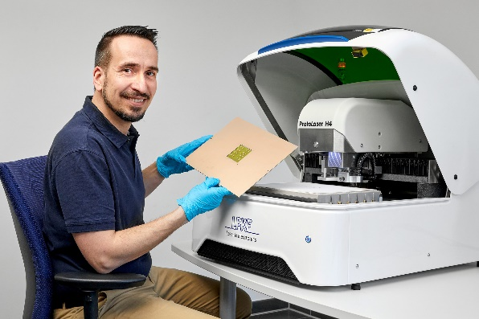
Fig. 1: Top results in the electronics laboratory - the new LPKF ProtoLaser H4.
The hardware achieves full performance with the easy-to-use system software. LPKF CircuitPro RP controls the entire production process - even for users without special expertise. Extensive libraries with material parameters, process flows for many common applications, a simple user interface and predefined laser tools simplify project planning. After loading the layout file, the software guides the user step by step through the production process. In-house prototyping significantly reduces the times of the individual design loops and is also suitable for small series.
How does this work in practice? This is shown in the practice report "4-layer PCBs in one day", which is now available for download free of charge from LPKF (bit.ly/3D0iF8Y). It describes the entire process from accepting the layout to the finished printed circuit board - and the new ProtoLaser H4 plays a decisive role here.

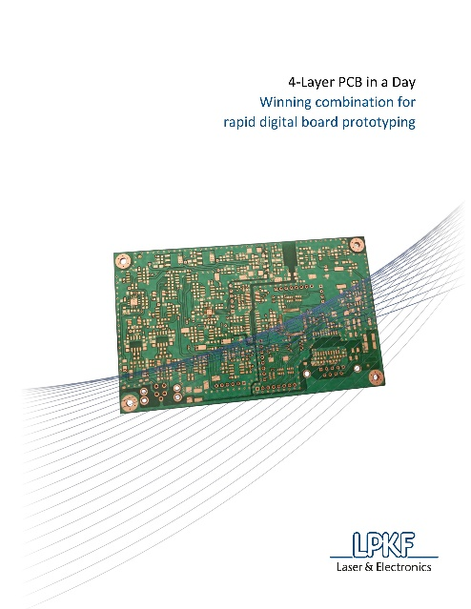
Fig. 2: The field report shows how a 4-layer PCB can be manufactured in your own laboratory thanks to the ProtoLaser H4 – in just one working day.

About LPKF
LPKF Laser & Electronics AG is a leading provider of laser-based solutions for the technology industry. Laser systems from LPKF are key elements in the manufacturing of printed circuit boards, microchips, automotive parts, solar modules, and many other components. Founded in 1976, the company is headquartered in Garbsen, near Hannover, Germany, and has subsidiaries and representative offices throughout the world. Around 20 percent of the workforce is engaged in research and development.

